Prashant Gupta 250840325052

Question 1: MapReduce (5 Marks)
You are given the Java source code for a MapReduce program AverageOrderValuePerMajorCategory.java.
Tasks:
- Compile the Java code and create a JAR file (one.jar).

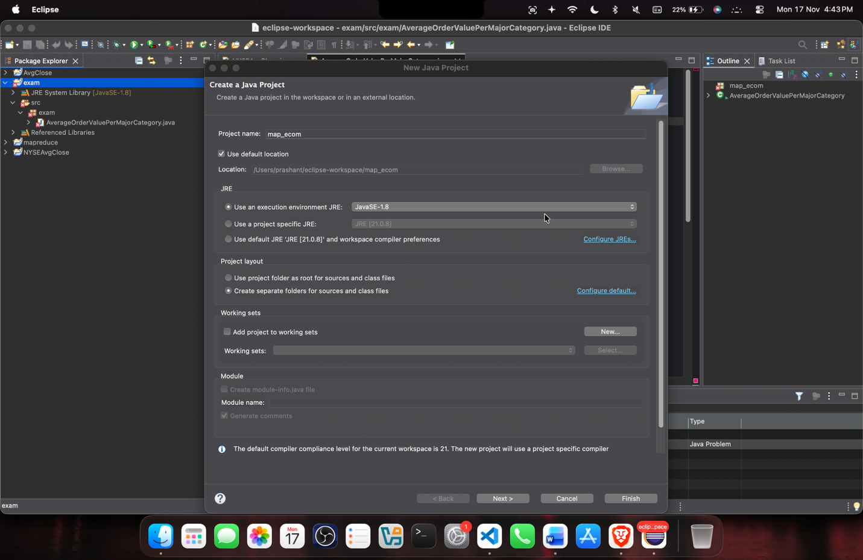
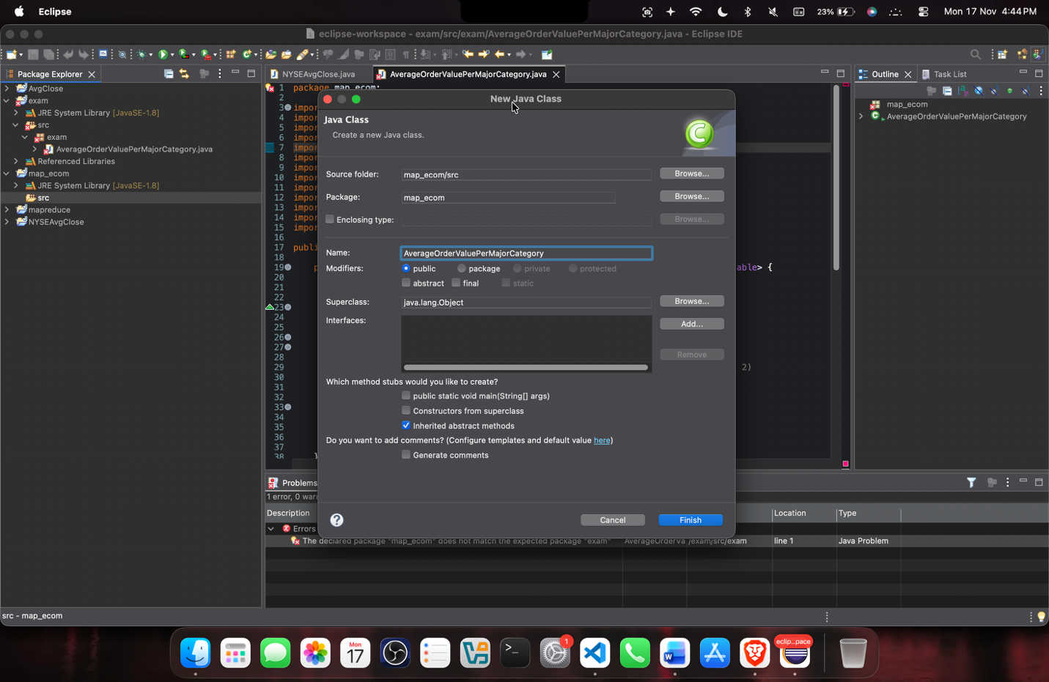
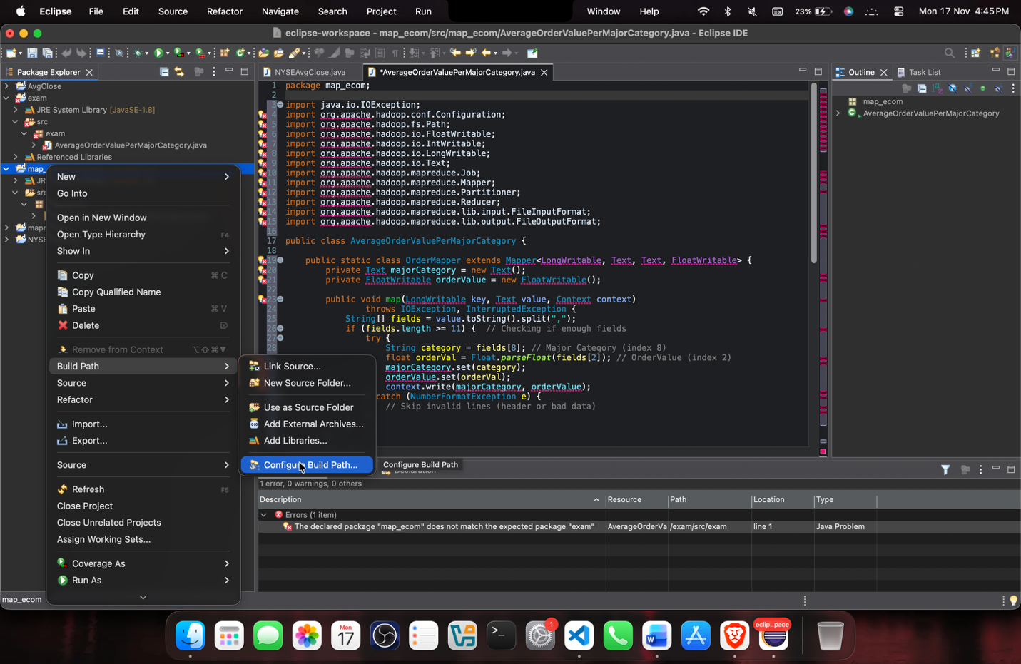
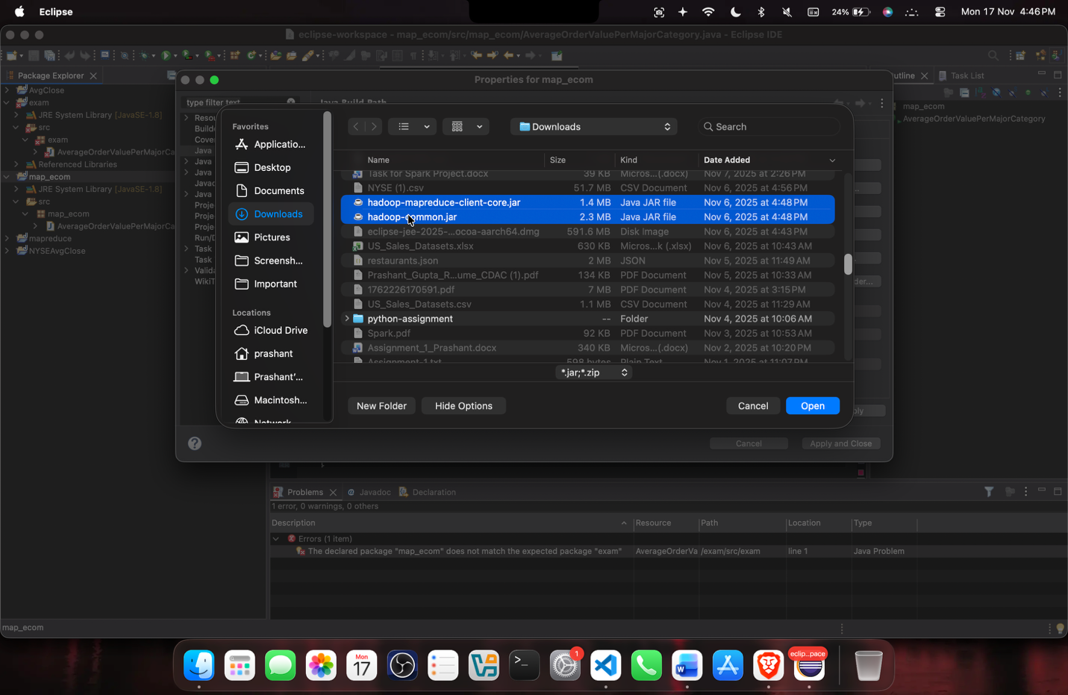
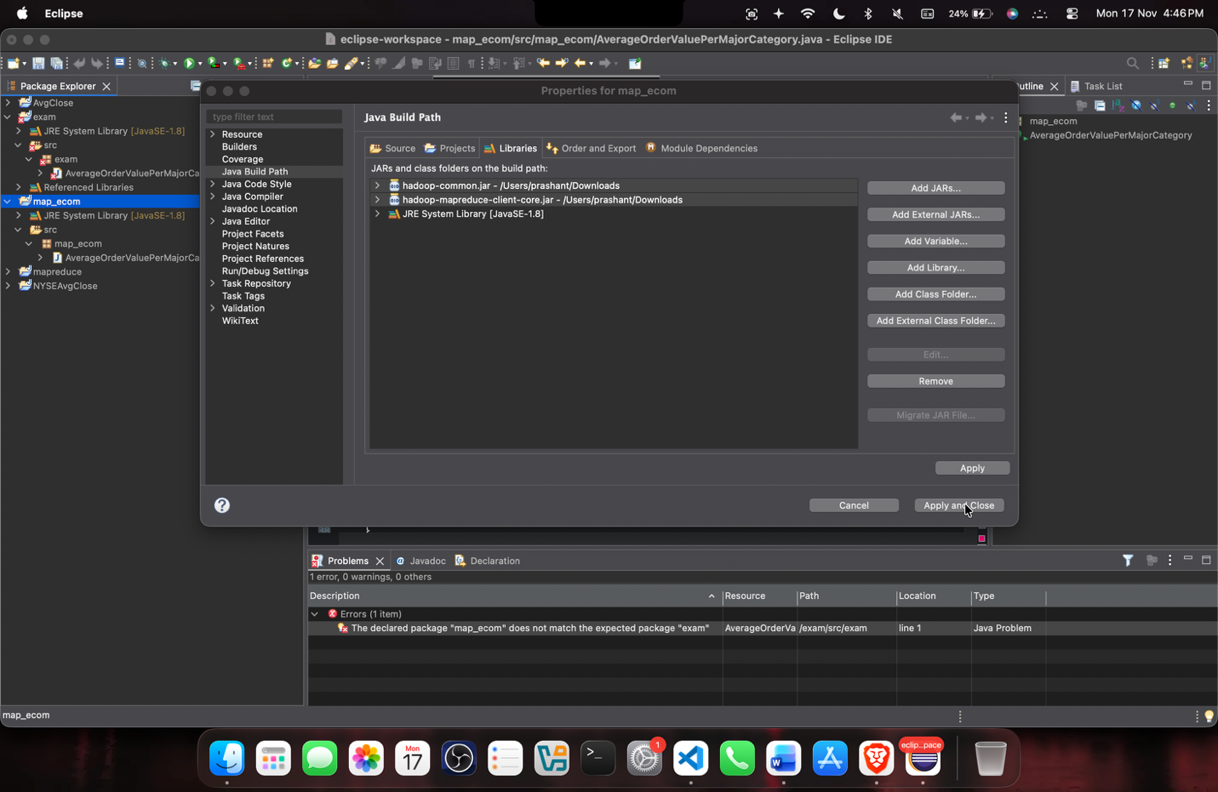
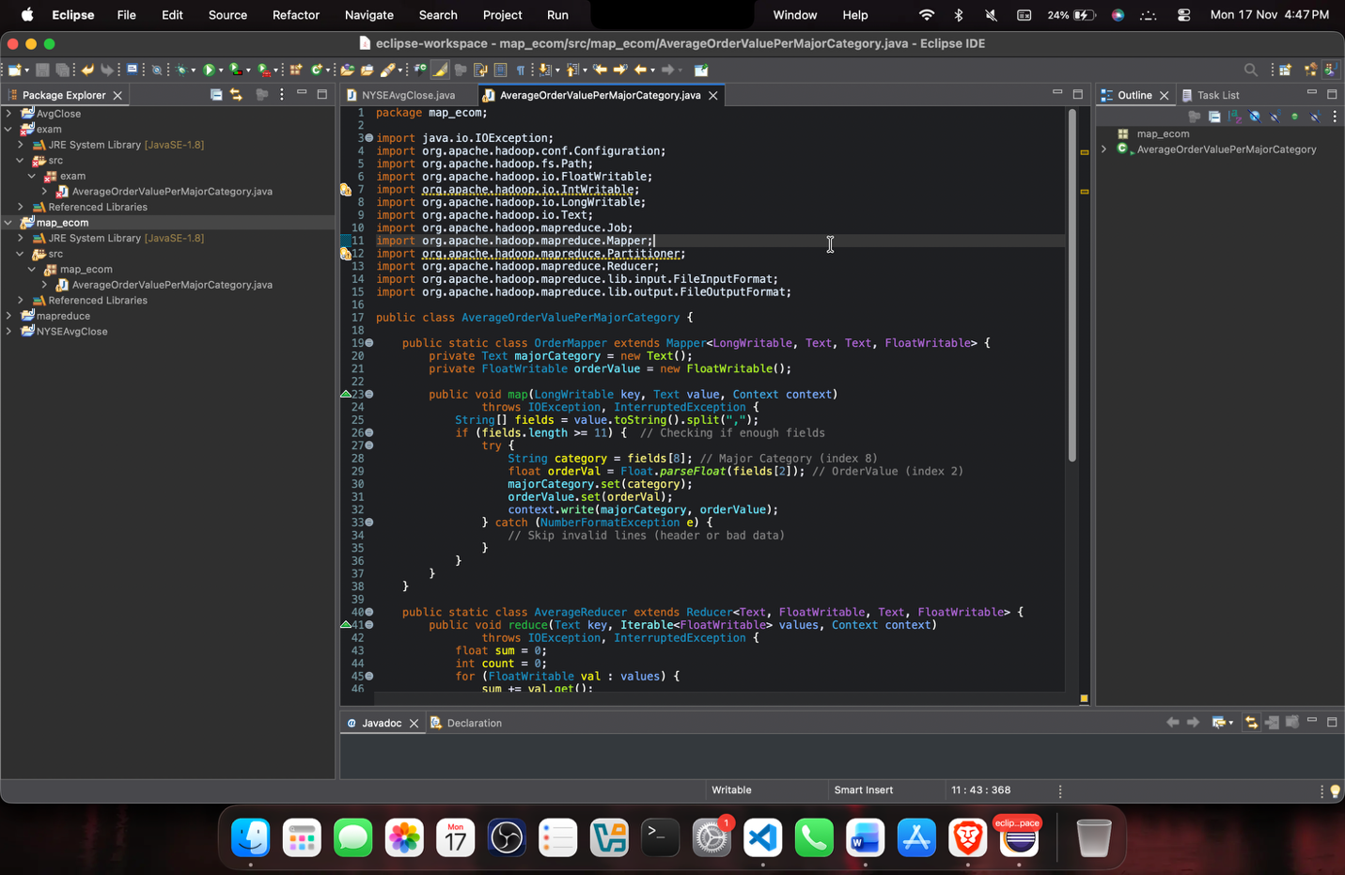
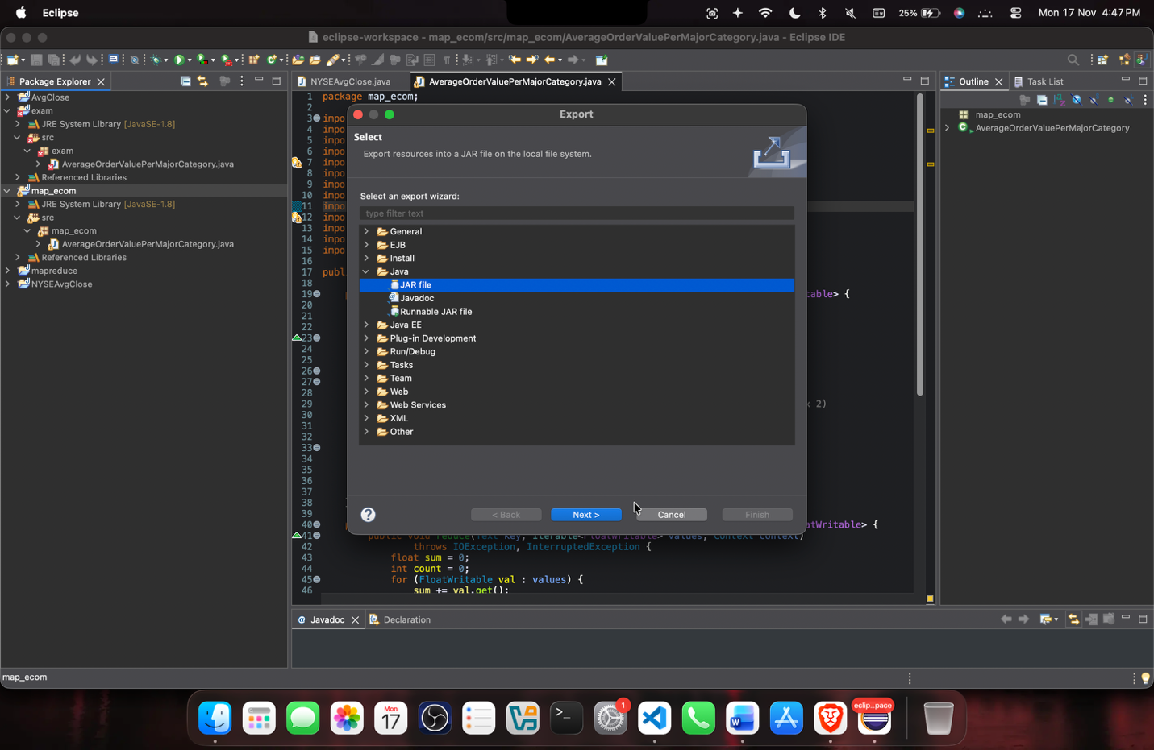
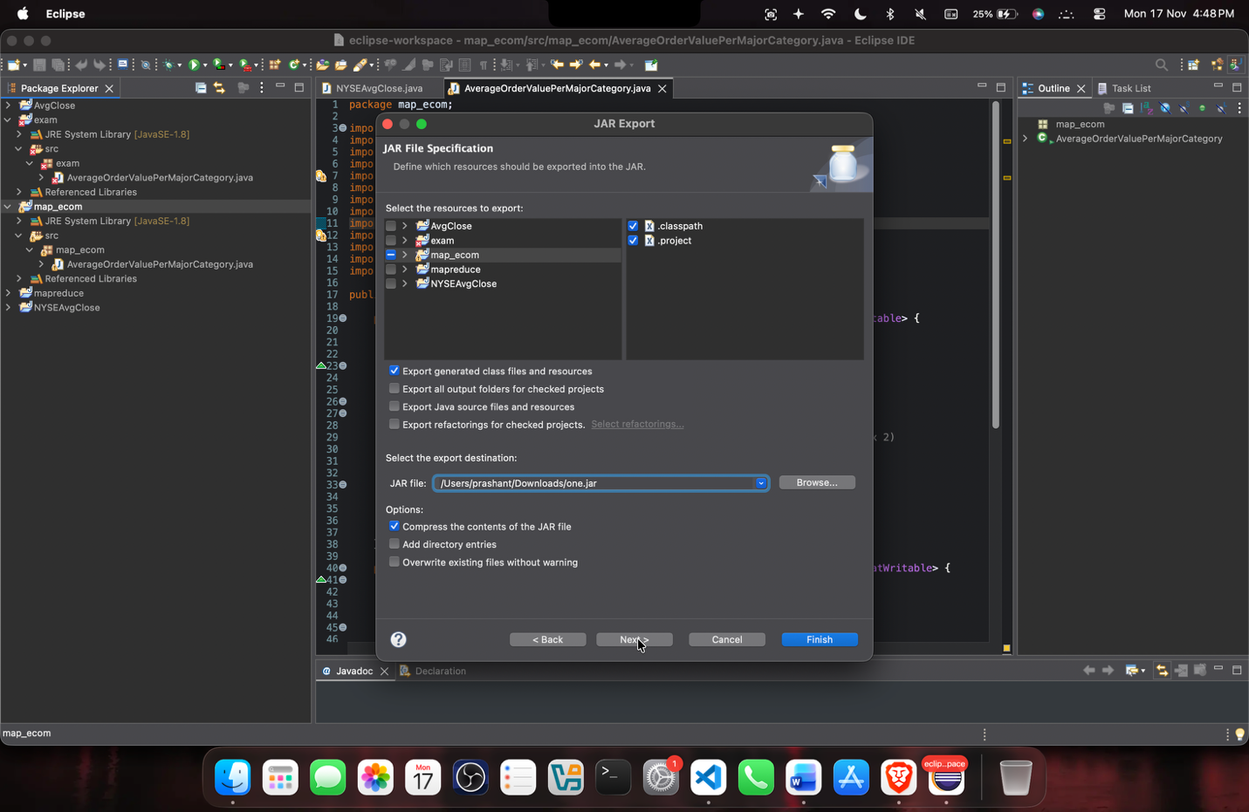
- Upload the input file ecom_data.csv,, check if all classes are present in jar

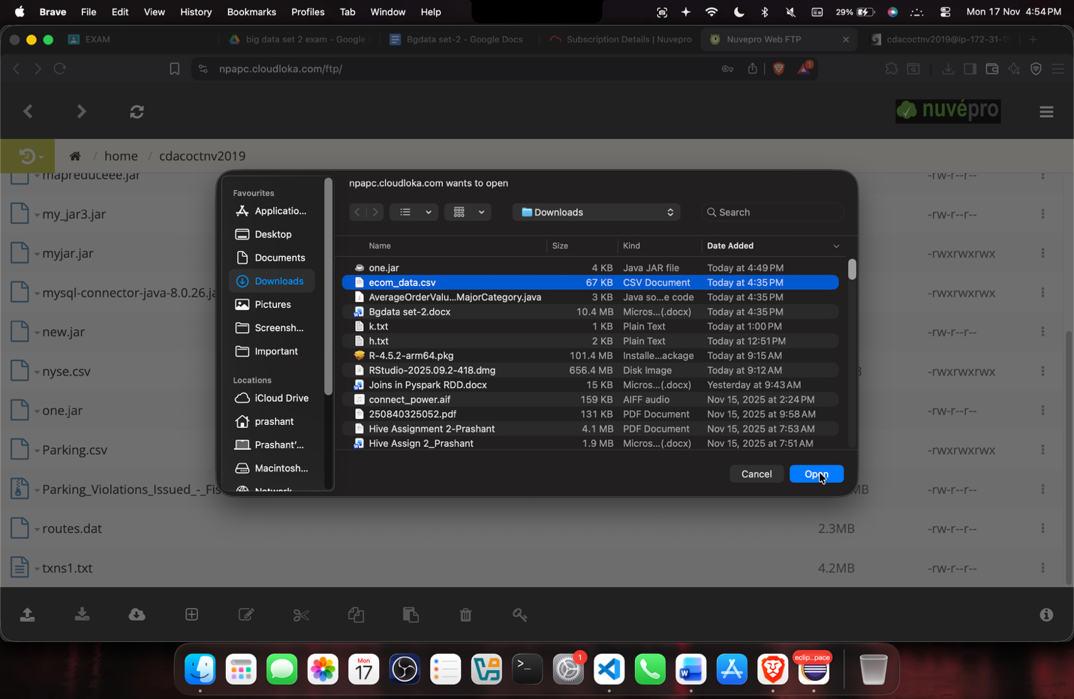
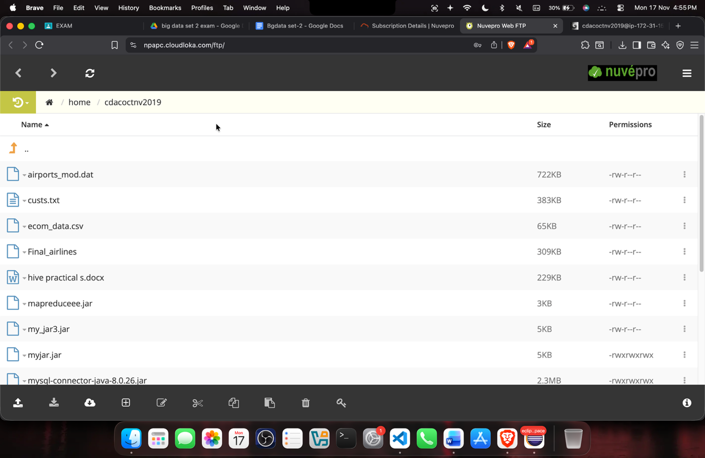

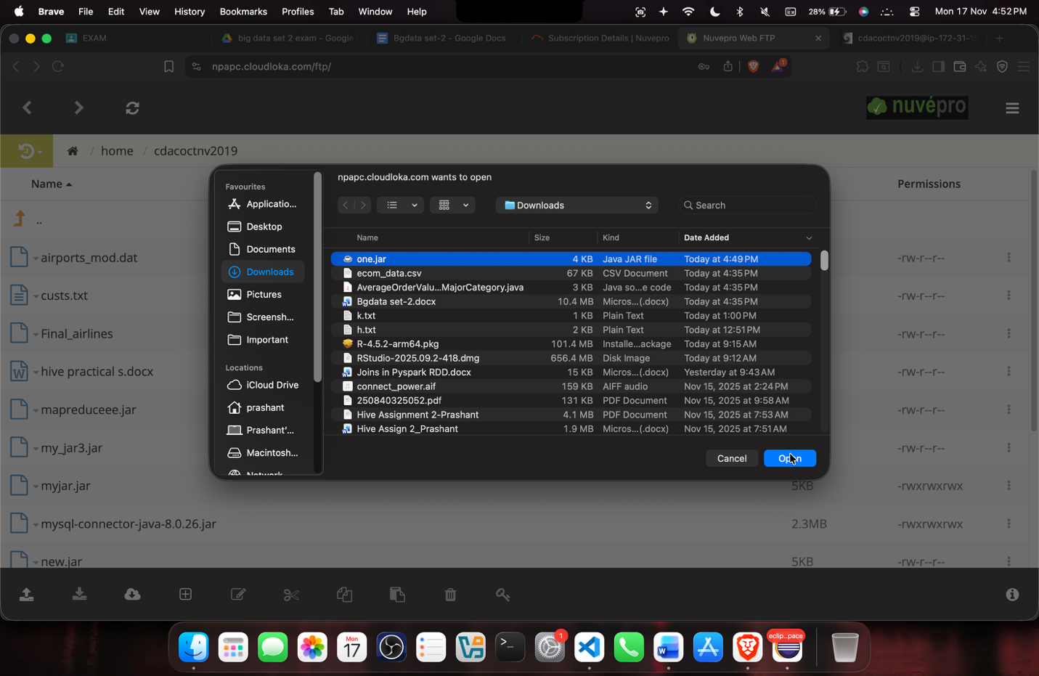
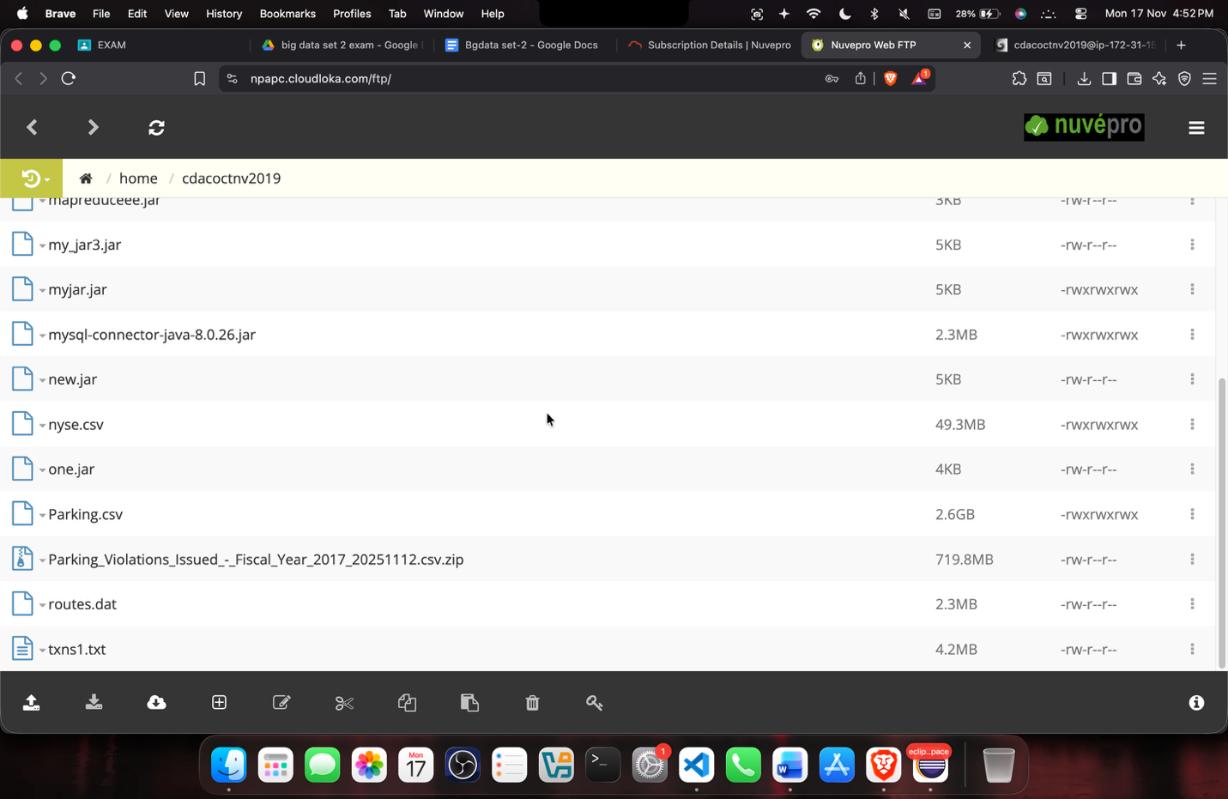

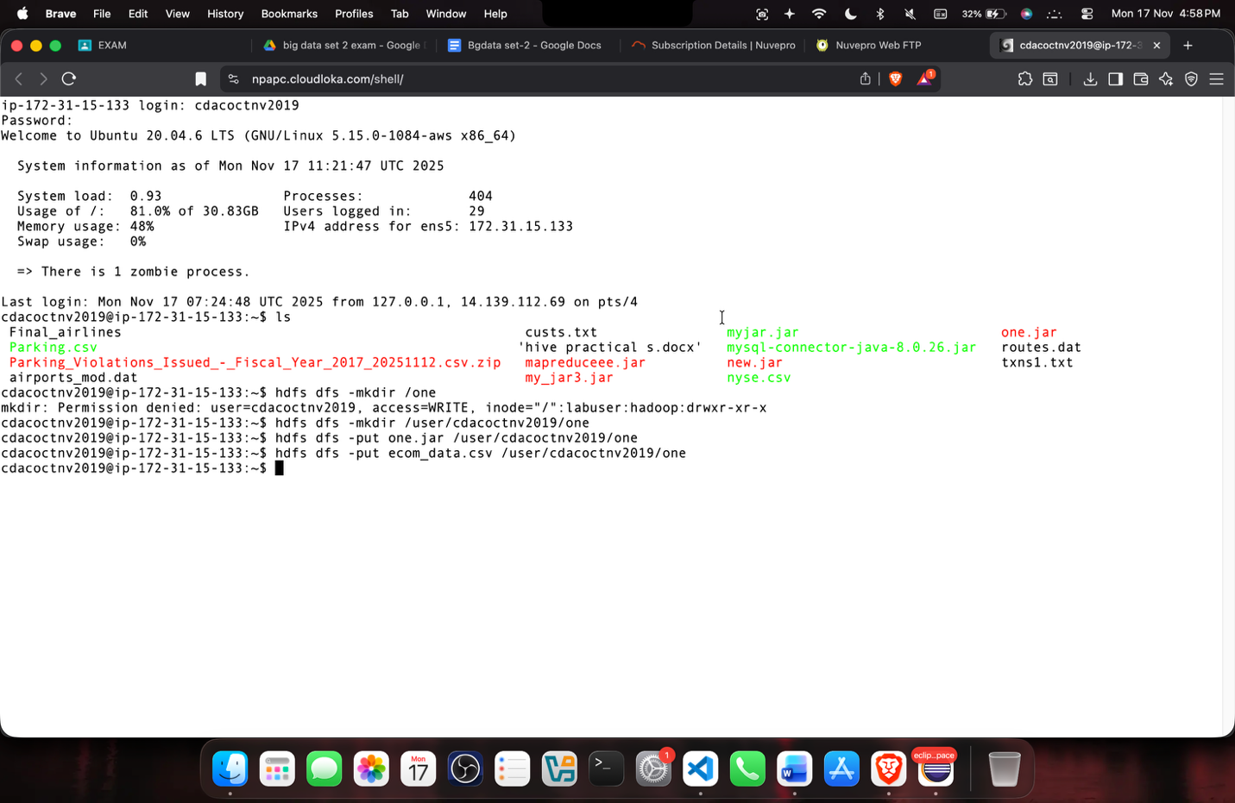

- Run the MapReduce job using the compiled JAR.
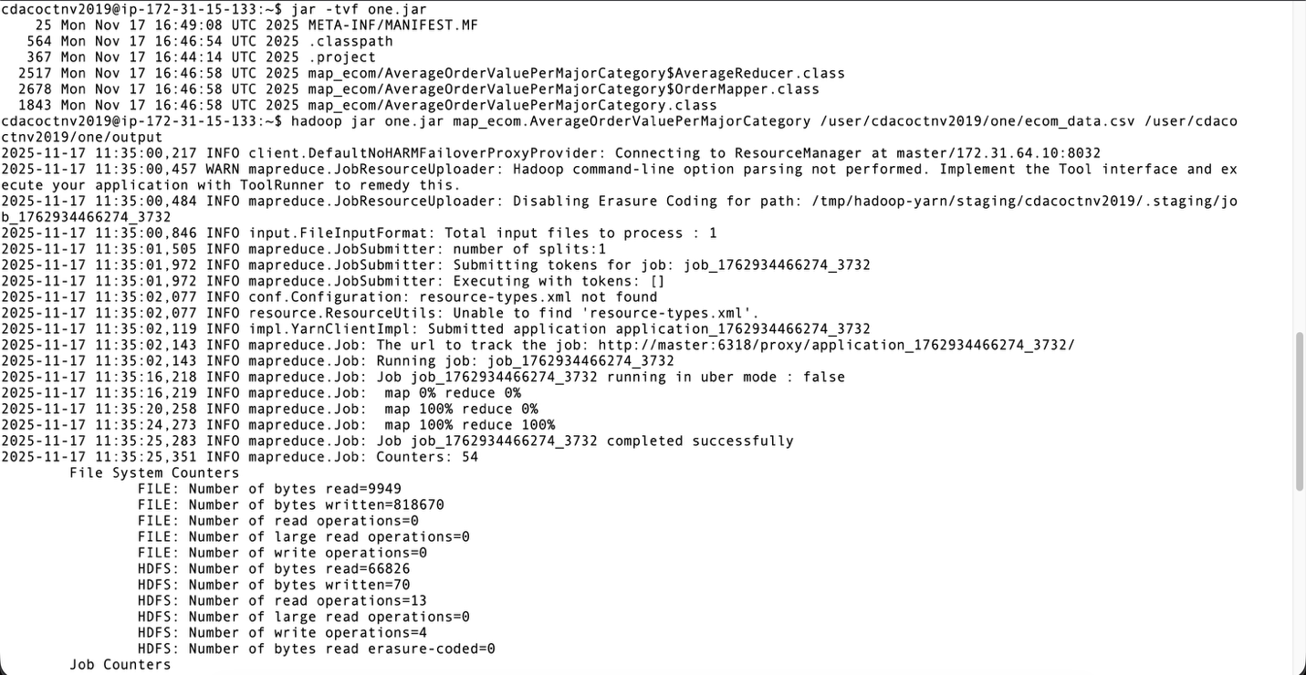


- Display the output (part-r-00000) and (part-m-00000)from HDFS.
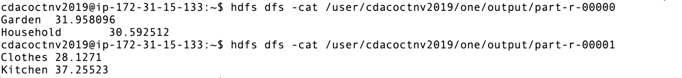
Question 2: Hive (18 Marks) (Retail data = ecom_data.csv)
Tasks:
- Create an external Hive table for the Retail Sales dataset and load data into it. (3 marks)
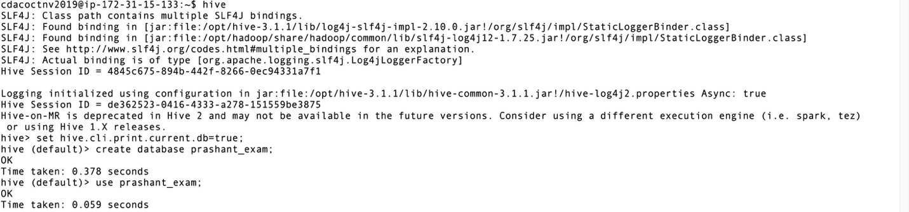
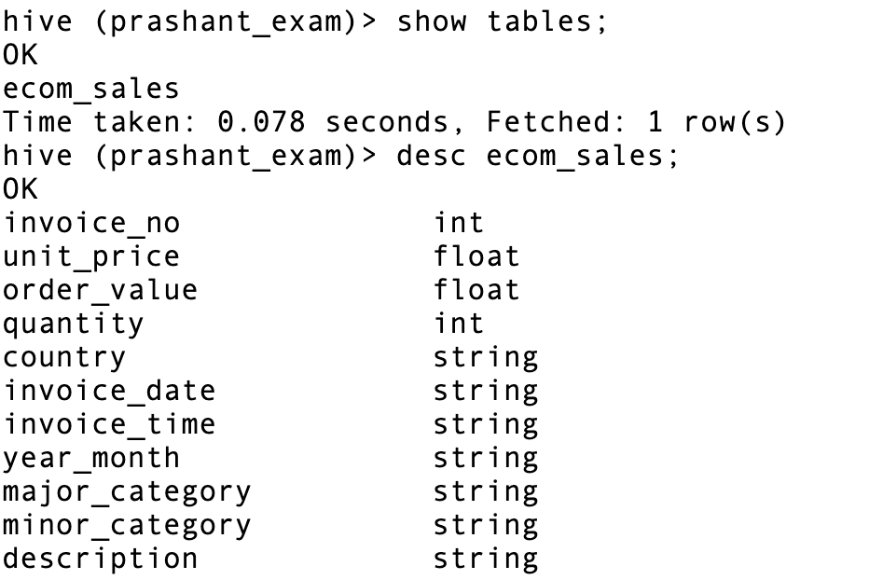
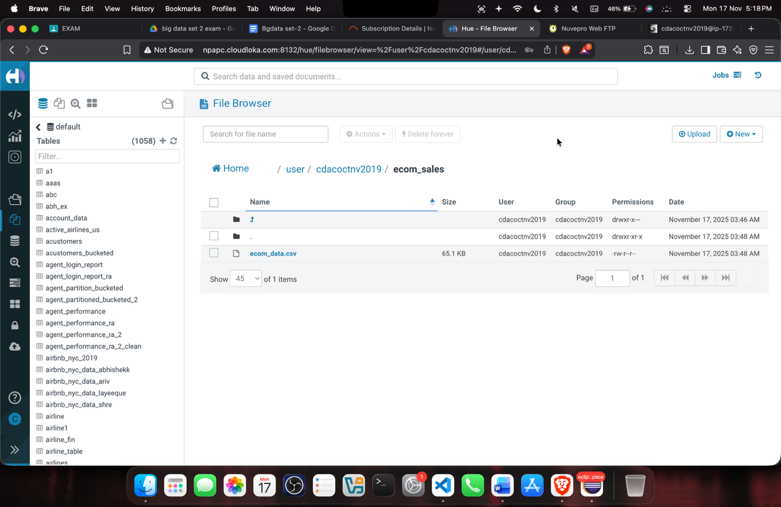
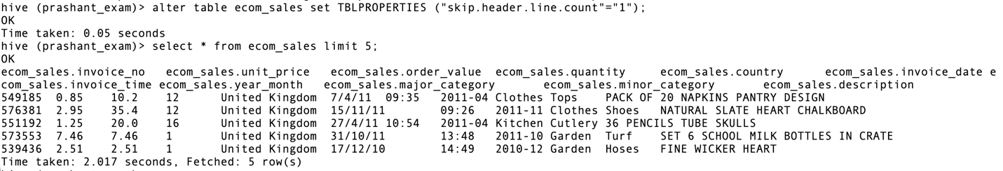
- Write a query to find the maximum OrderValue for each Major Category. (2 marks)
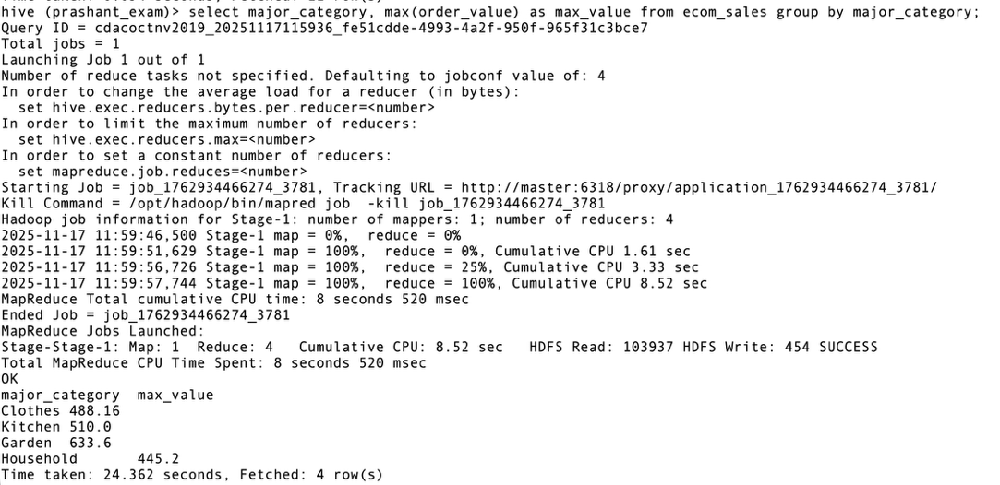

- Create a partitioned table by Country and load the data accordingly. Also show the partitions created. (3 marks)
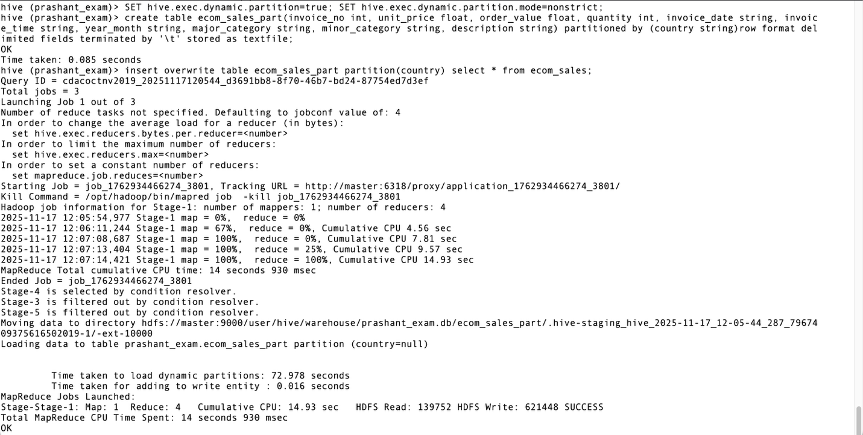

- Write a query to find the top 5 Minor Categories with the highest number of orders using CTE. (2 marks)

- Create a managed table copying data from the external table. (2 marks)
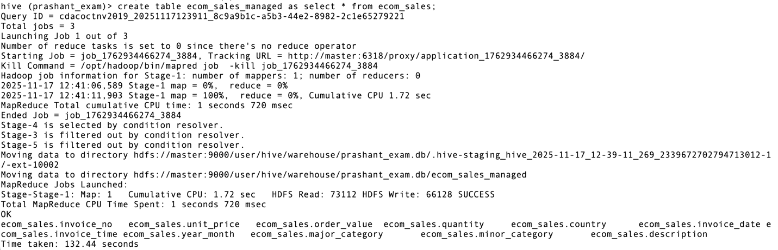

- Perform a full outer join between two copies of the table based on the InvoiceNo. (2 marks)

- Create a new managed table retail_sales_orc stored as ORC format. (4 marks)
Insert data into this ORC table from the existing managed table retail_sales_managed.
Fetch data from both retail_sales_managed and retail_sales_orc.
Compare the query performance between the two tables and comment on any differences observed.
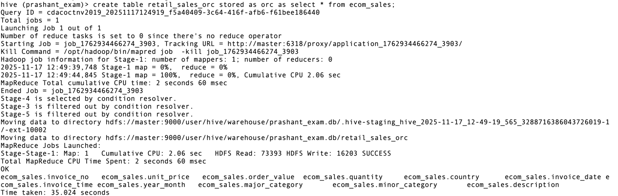
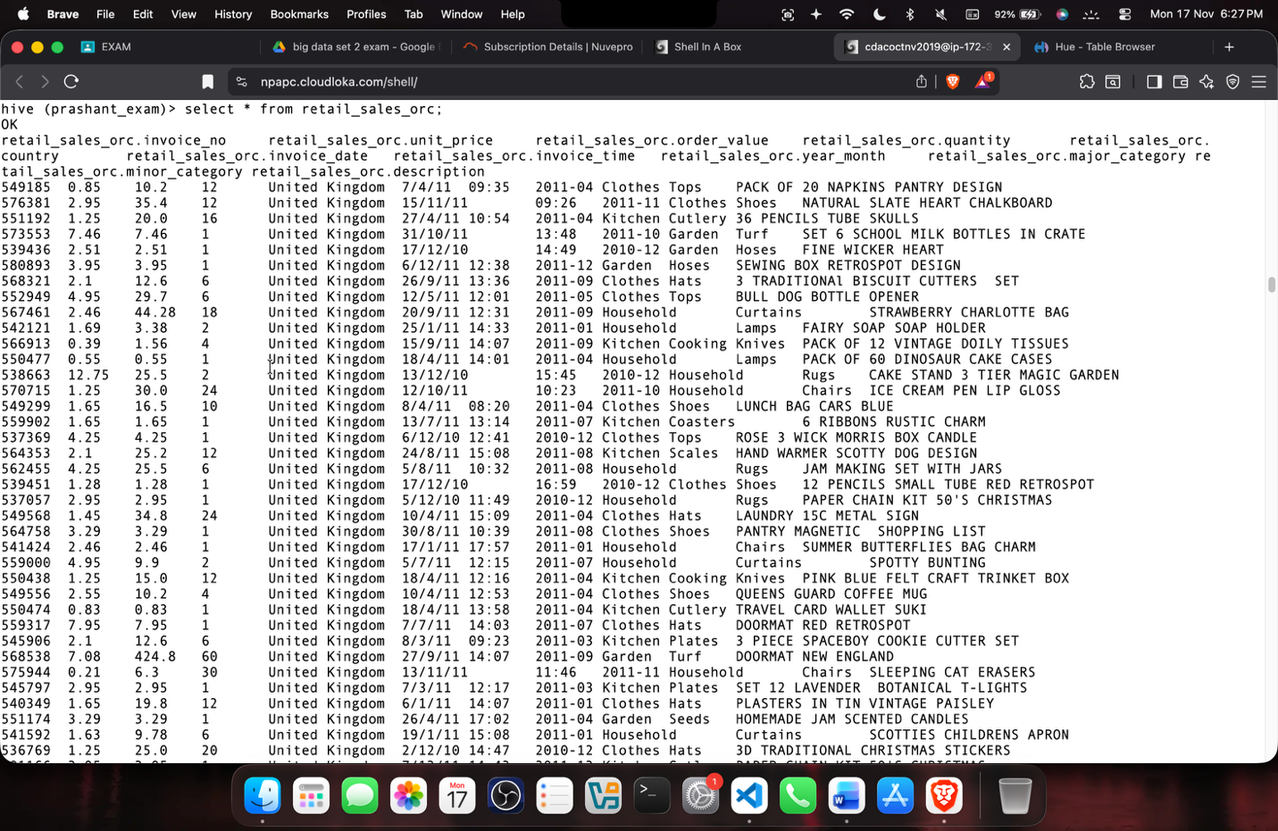
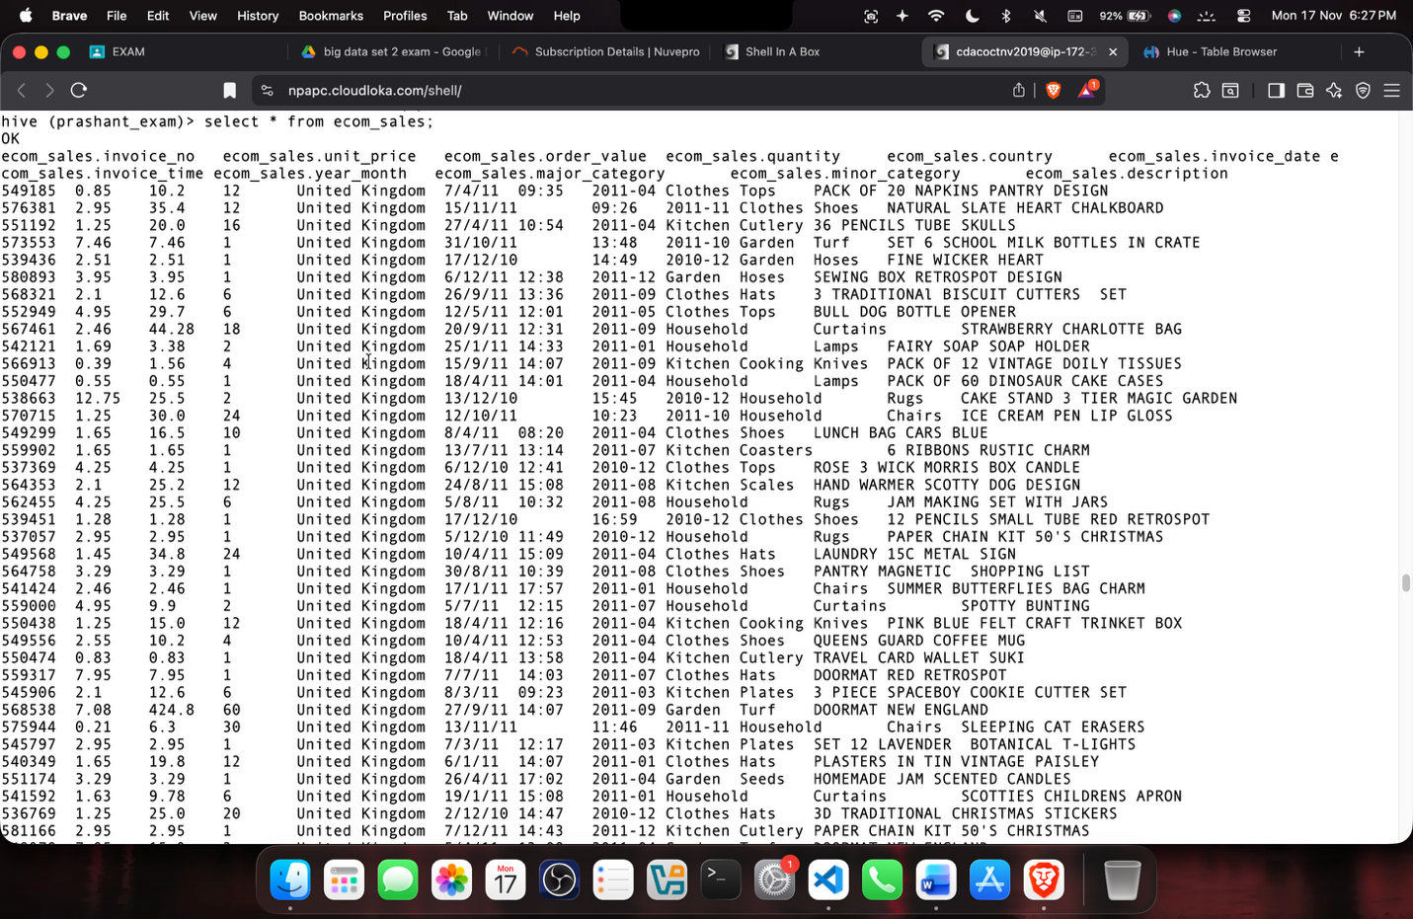
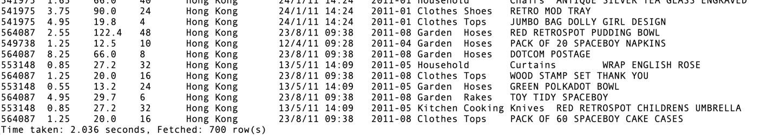
In ORC, the data is stored in optimized format and the table is compressed, so the retrieval of the data is faster in ORC format. In normal text format the data retrieval is slower. We can see this with the help of the time taken by both the results.

Question 3: PySpark RDD (12 Marks)
Load the RetailSales.csv file into an RDD. Split each line by commas.
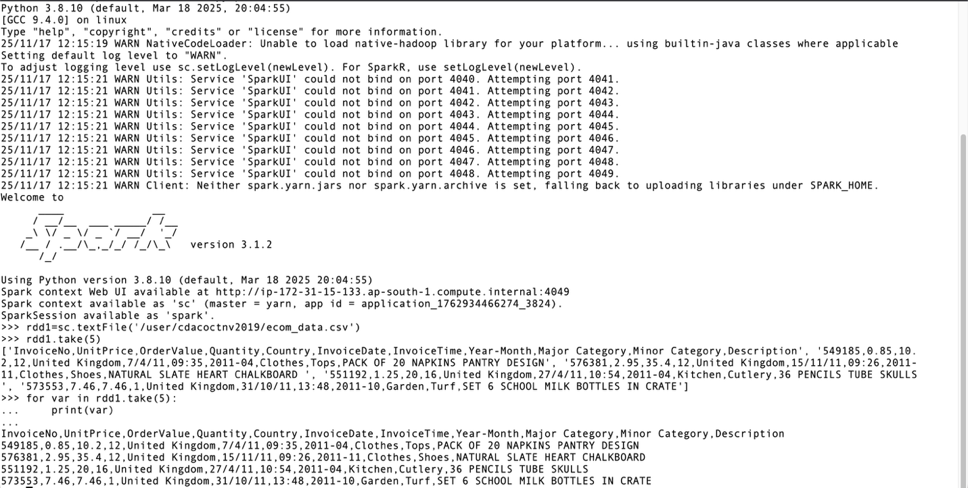
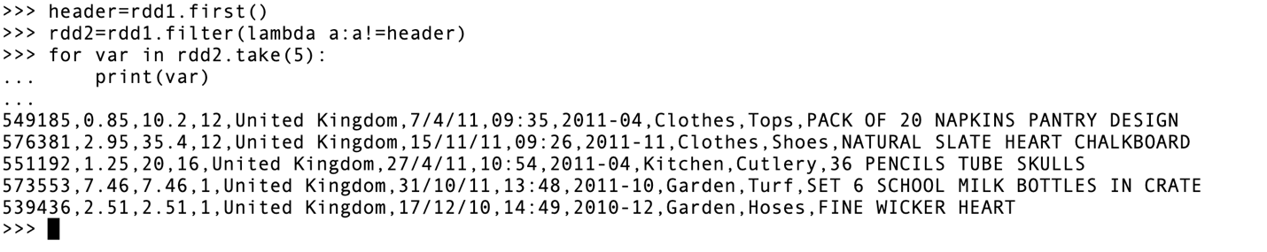
1. Top Major Categories by Total Order Value (6 Marks)
Create an RDD of (Major Category, OrderValue) pairs.
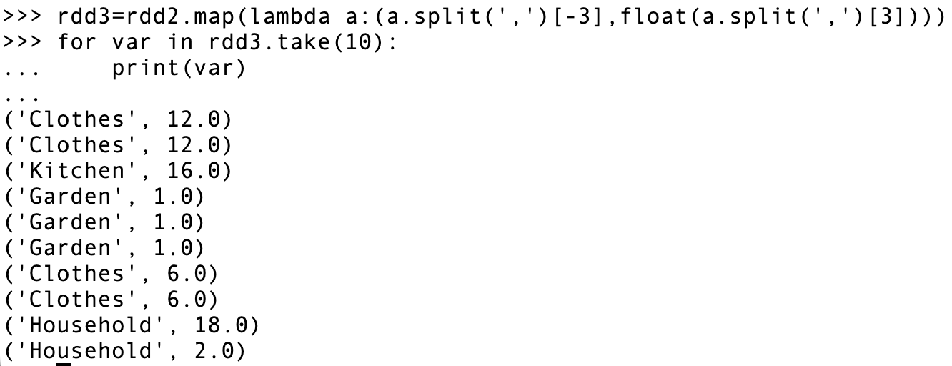
Sum the OrderValue for each Major Category.
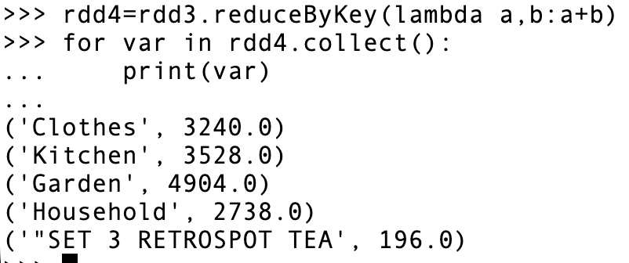
Display the top 5 Major Categories with the highest total Order Value.
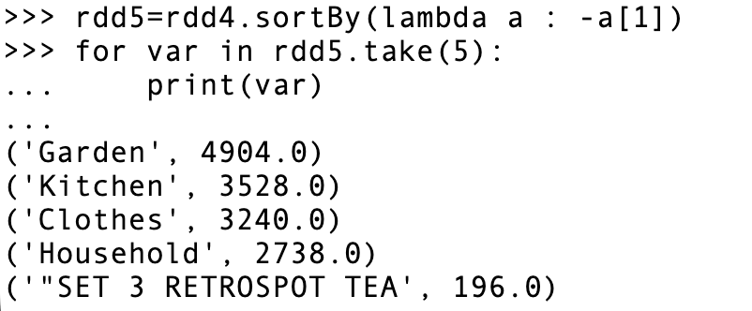
2. Top Minor Categories by Product Count (6 Marks)
- Create an RDD of (Minor Category, 1) pairs.
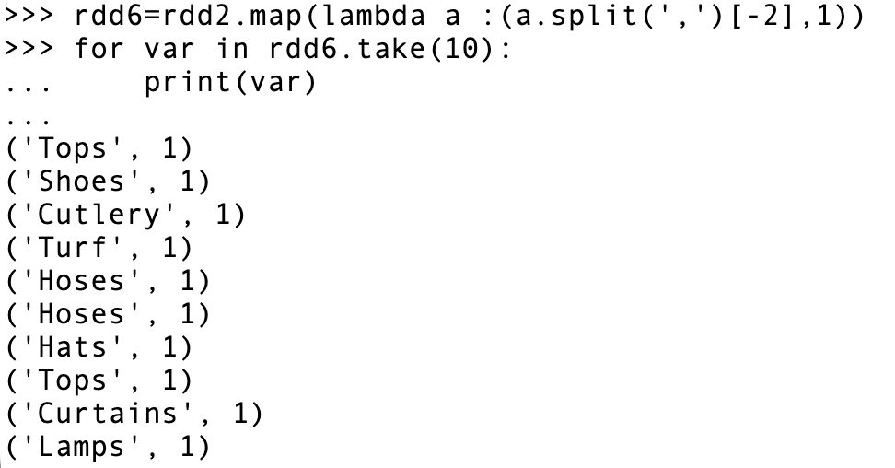
- Count the total number of orders for each Minor Category.
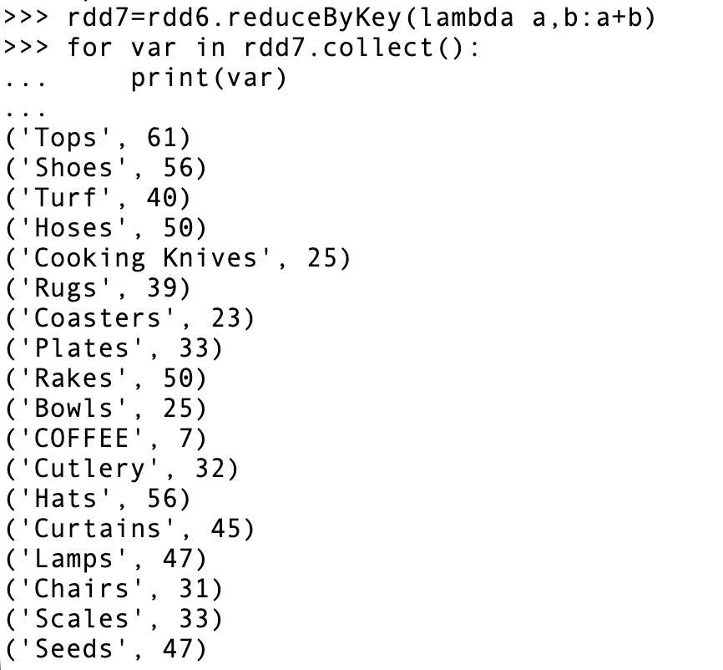

- Display the top 5 Minor Categories with the highest number of orders.
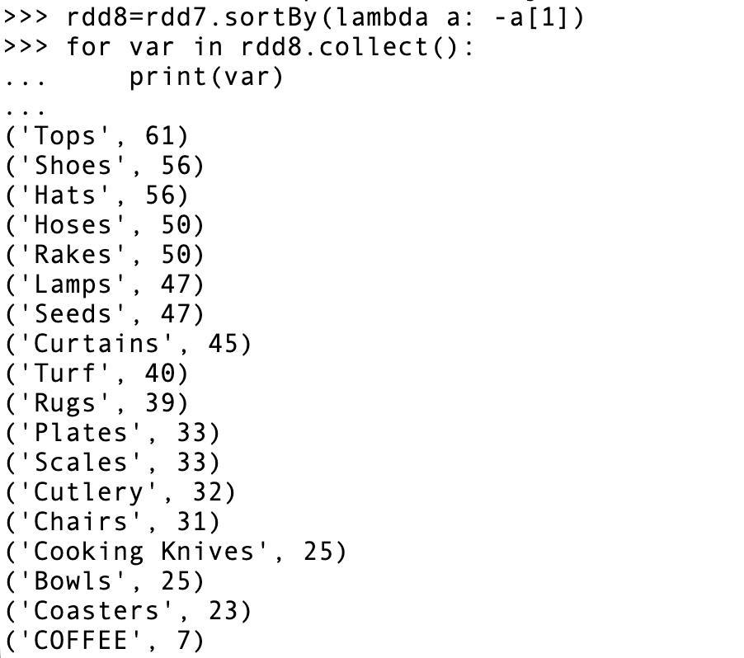
Question 4: Kafka (5 Marks)
Tasks:
- Create a Kafka topic named retail_topic with a replication factor of 1 and a single partition.

$KAFKA_HOME/bin/kafka-topics.sh --create --topic retail_topic69 --bootstrap-server master:9092

- Start a Kafka consumer that listens to the retail_topic and displays incoming messages in real-time.

$KAFKA_HOME/bin/kafka-console-consumer.sh --topic retail_topic69 --from-beginning --bootstrap-server master:9092

- Start a Kafka producer that sends messages to the retail_topic.

$KAFKA_HOME/bin/kafka-console-producer.sh --topic retail_topic69 --bootstrap-server master:9092

- Type any text into the producer console — the same text should immediately appear on the consumer console in real-time.

